**NORMALIZATION:**

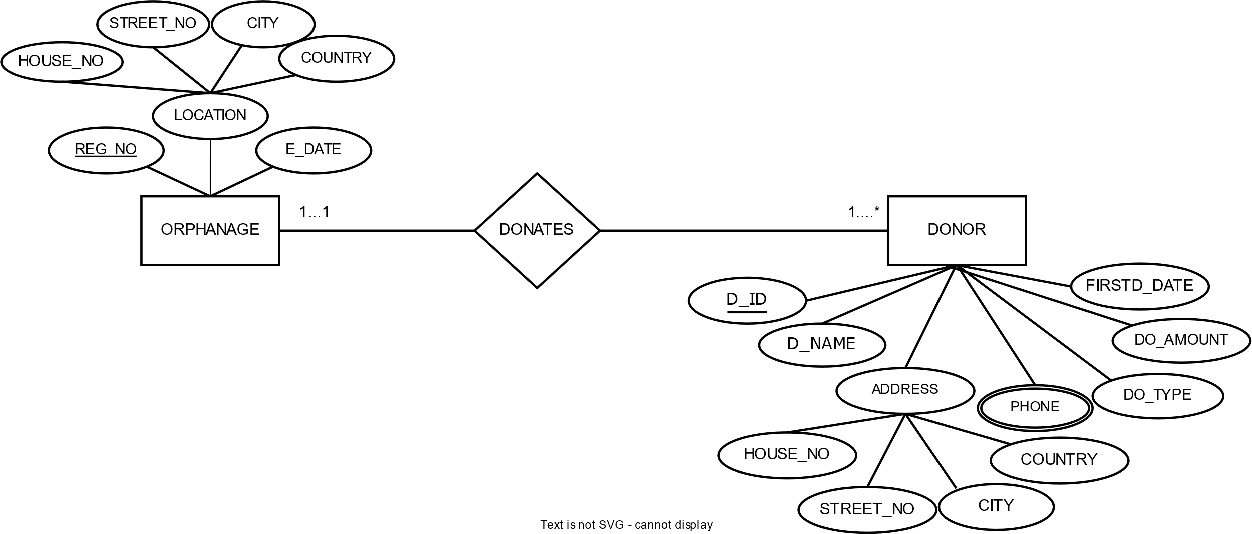

**DONATES:**

UNF:

REG_NO, E_DATE, HOUSE_NO, STREET_NO, CITY, COUNTRY, D_ID, D_NAME,

HOUSE_NO, STREET_NO, CITY, COUNTRY, PHONE, DO_TYPE, DO_AMOUNT, FIRSTD_DATE

1NF:

PHONE is a multivalued attribute

REG_NO, E_DATE, HOUSE_NO, STREET_NO, CITY, COUNTRY, D_ID, D_NAME,

HOUSE_NO, STREET_NO, CITY, COUNTRY, DO_TYPE, DO_AMOUNT, FIRSTD_DATE

2NF:

1. REG_NO, E_DATE, HOUSE_NO, STREET_NO, CITY, COUNTRY
2. DI_D, D_NAME, HOUSE_NO, STREET_NO, CITY, COUNTRY, DO_TYPE, DO_AMOUNT, FIRSTD_DATE, REG_NO, PHONE_ID
3. PHONE_ID, PHONE

3NF:

1. REG_NO, E_DATE, ADD_ID
2. ADD_ID, HOUSE_NO, STREET_NO, CITY, COUNTRY
3. DI_D, D_NAME, REG_NO, ADD_ID, PHONE_ID
4. ADD_ID, HOUSE_NO, STREET_NO, CITY, COUNTRY
5. D_ID, DO_TYPE, DO_AMOUNT, FIRSTD_DATE,
6. PHONE_ID, PHONE

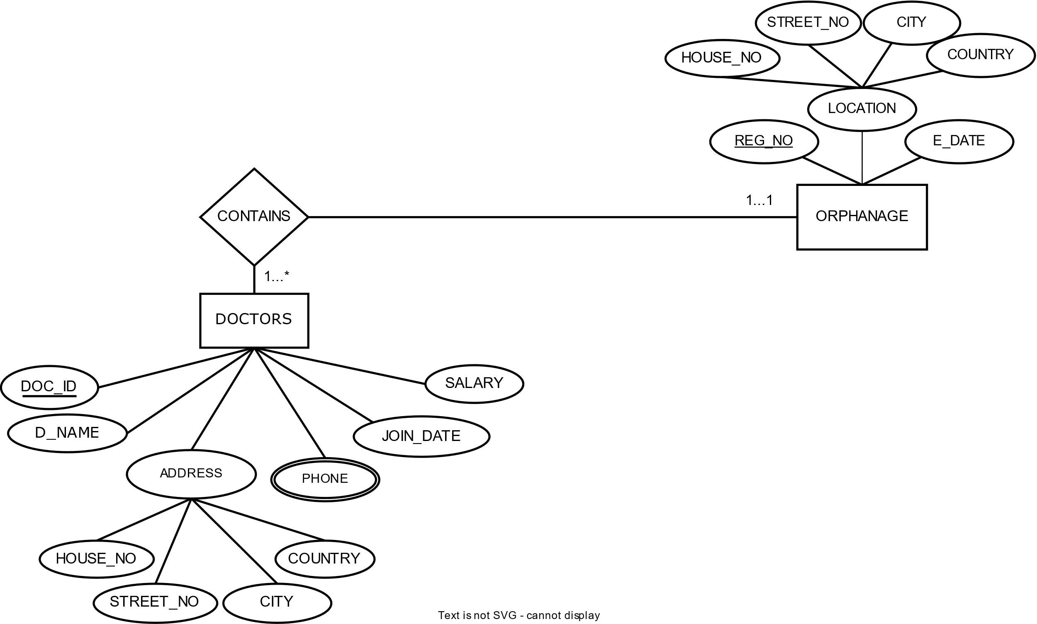

**CONTAINS:**

UNF:

REG_NO, E_DATE, HOUSE_NO, STREET_NO, CITY, COUNTRY, DOC_ID, DO_NAME, HOUSE_NO, STREET_NO, CITY, COUNTRY, PHONE, JOIN_DATE, SALARY

1NF:

PHONE is a multivalued attribute

REG_NO, E_DATE, HOUSE_NO, STREET_NO, CITY, COUNTRY, DOC_ID, DO_NAME, HOUSE_NO, STREET_NO, CITY, COUNTRY, JOIN_DATE, SALARY

2NF:

1. REG_NO, E_DATE, HOUSE_NO, STREET_NO, CITY, COUNTRY
2. DOC_ID, DO_NAME, HOUSE_NO, STREET_NO, CITY, COUNTRY, JOIN_DATE, SALARY, REG_NO, PHONE_ID
3. PHONE_ID, PHONE

3NF:

1. REG_NO, E_DATE, ADD_ID
2. ADD_ID, HOUSE_NO, STREET_NO, CITY, COUNTRY
3. DOC_ID, DO_NAME, JOIN_DATE, SALARY, REG_NO, PHONE_ID, ADD_ID
4. ADD_ID, HOUSE_NO, STREET_NO, CITY, COUNTRY
5. PHONE_ID, PHONE

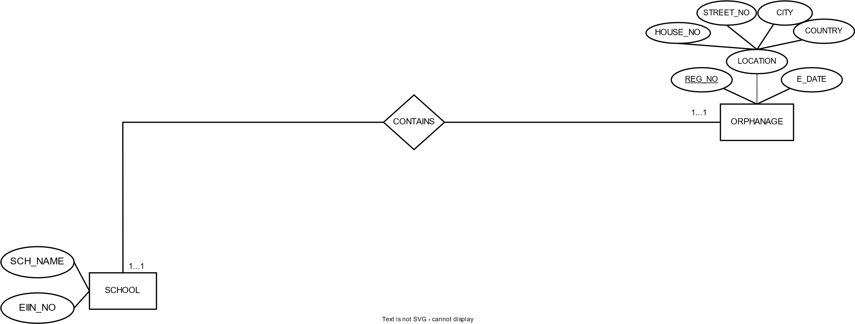

**CONTAIN**:

UNF:

REG_NO, REG_NO, E_DATE, HOUSE_NO, STREET_NO, CITY, COUNTRY, SCH_NAME, EIIN_NO

1NF:

REG_NO, REG_NO, E_DATE, HOUSE_NO, STREET_NO, CITY, COUNTRY, SCH_NAME, EIIN_NO

2NF:

1. REG_NO, E_DATE, HOUSE_NO, STREET_NO, CITY, COUNTRY
2. EIIN_NO, SCH_NAME, REG_NO

3NF:

1. REG_NO, E_DATE, ADD_ID
2. ADD_ID, HOUSE_NO, STREET_NO, CITY, COUNTRY
3. EIIN_NO, SCH_NAME, REG_NO

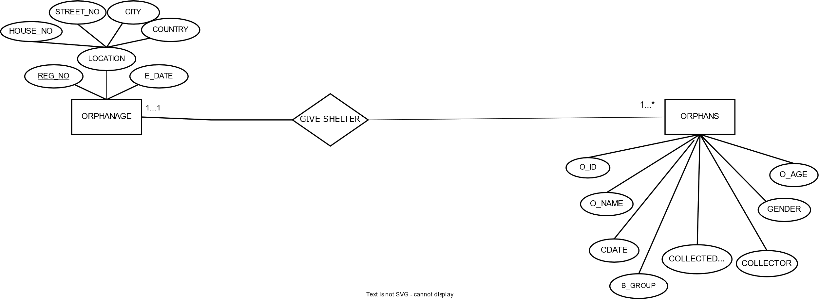

**GIVE SHELTER:**

UNF:

REG_NO, REG_NO, E_DATE, HOUSE_NO, STREET_NO, CITY, COUNTRY, O_ID, O_NAME, C_DATE, COLLECTED_FROM, COLLECTOR, B_GROUP, GENDER, O_AGE

1NF:

REG_NO, REG_NO, E_DATE, HOUSE_NO, STREET_NO, CITY, COUNTRY, O_ID, O_NAME, C_DATE, COLLECTED_FROM, COLLECTOR, B_GROUP, GENDER, O_AGE

2NF:

1. REG_NO, E_DATE, HOUSE_NO, STREET_NO, CITY, COUNTRY
2. O_ID, O_NAME, C_DATE, COLLECTED_FROM, COLLECTOR, B_GROUP, GENDER, O_AGE, REG_NO

3NF:

1. REG_NO, E_DATE, ADD_ID
2. ADD_AD, HOUSE_NO, STREET_NO, CITY, COUNTRY
3. O_ID, O_NAME, B-GROUP, GENGER, O_AGE, REG_NO
4. O_ID, C_DATE, COLLECTED_FROM, COLLECTOR

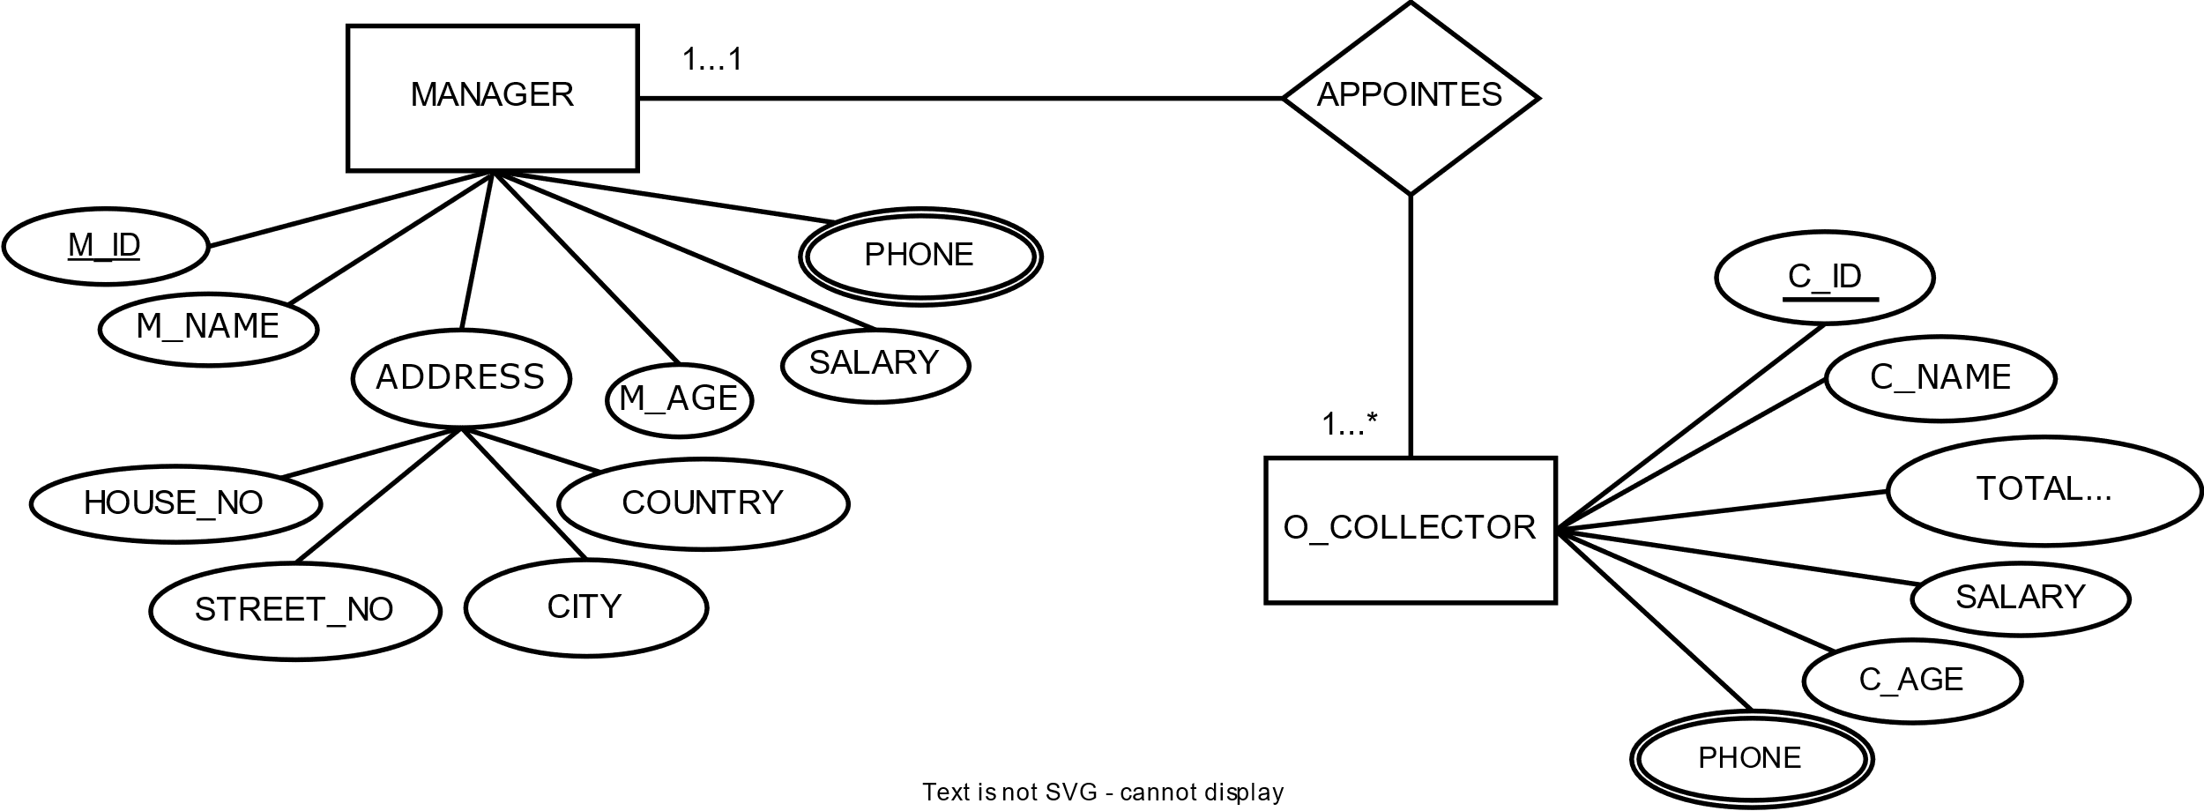

**APPOINTS:**

UNF:

M_ID, M_NAME, HOUSE_NO, STREET_NO, CITY, COUNTRY, M_AGE, SALARY, PHONE, C_ID, C_NAME, TOTAL_COLLECTION, SALARY, C_AGE, PHONE

1NF:

PHONE is a multivalued attribute

M_ID, M_NAME, HOUSE_NO, STREET_NO, CITY, COUNTRY, M_AGE, SALARY, C_ID, C_NAME, TOTAL_COLLECTION, SALARY, C_AGE,

2NF:

1. M_ID, M_NAME, HOUSE_NO, STREET_NO, CITY, COUNTRY, M_AGE, SALARY, PHONE_ID
2. PHONE_ID, PHONE
3. C_ID, C_NAME, TOTAL_COLLECTION, SALARY, C_AGE, M_ID, PHONE_ID
4. PHONE_ID, PHONE

3NF:

1. M_ID, M_NAME, M_AGE, SALARY, PHONE_ID, ADD_ID
2. ADD_ID, HOUSE_NO, STREET_NO, CITY, COUNTRY
3. PHONE_ID, PHONE
4. C_ID, C_NAME, TOTAL_COLLECTION, SALARY, C_AGE, M_ID, PHONE_ID
5. PHONE_ID, PHONE

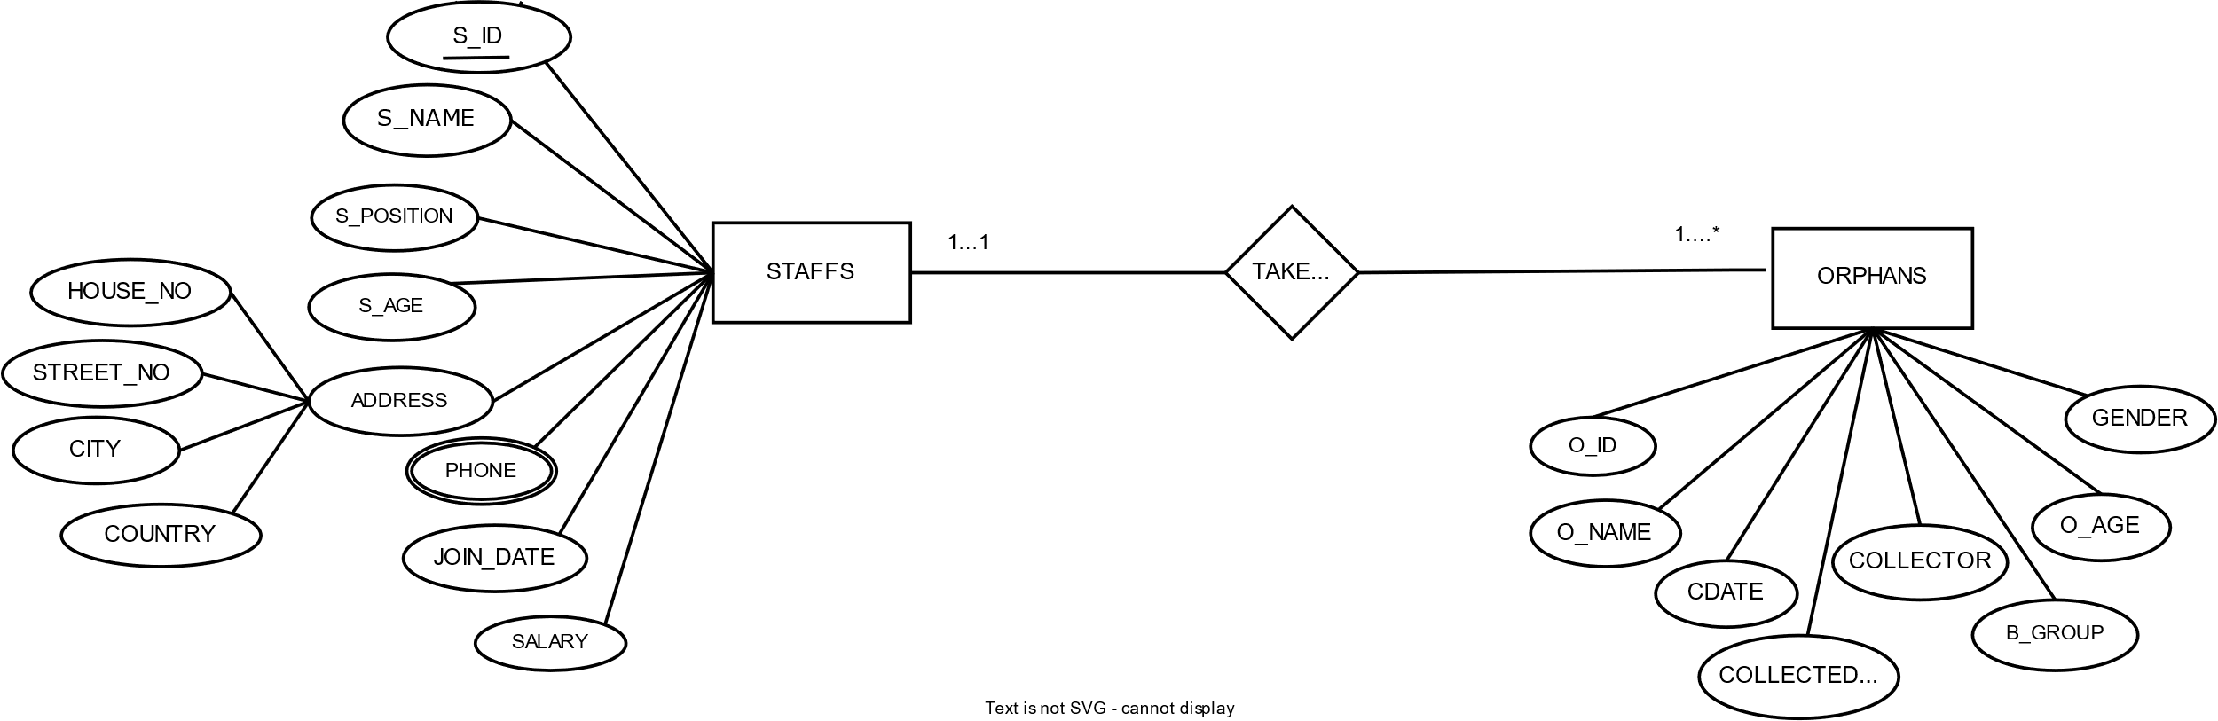**TAKE CARE:**

UNF:

S_ID, S_NAME, S_POSITION, S_AGE, HOUSE_NO, STREET_NO, CITY, COUNTRY, PHONE, JOIN_DATE, SALARY, O_ID, O_NAME, C_DATE, COLLECTED_FROM, COLLECTOR, B_GROUP, GENDER, O_AGE

1NF:

PHONE is a multivalued attribute

S_ID, S_NAME, S_POSITION, S_AGE, HOUSE_NO, STREET_NO, CITY, COUNTRY, JOIN_DATE, SALARY, O_ID, O_NAME, C_DATE, COLLECTED_FROM, COLLECTOR, B_GROUP, GENDER, O_AGE

2NF:

1. S_ID, S_NAME, S_POSITION, S_AGE, HOUSE_NO, STREET_NO, CITY, COUNTRY, JOIN_DATE, SALARY, PHONE_ID
2. PHONE_ID, PHONE
3. O_ID, O_NAME, C_DATE, COLLECTED_FROM, COLLECTOR, B_GROUP, GENDER, O_AGE, S_ID

3NF:

1. S_ID, S_NAME, S_AGE, JOIN_DATE, ADD_ID, PHONE_ID
2. S_ID, S_POSITION, SALARY
3. ADD_ID, HOUSE_NO, STREET_NO, CITY, COUNTRY
4. PHONE_ID, PHONE
5. O_ID, O_NAME, B-GROUP, GENGER, O_AGE, S_ID
6. O_I D, C_DATE, COLLECTED_FROM, COLLECTOR

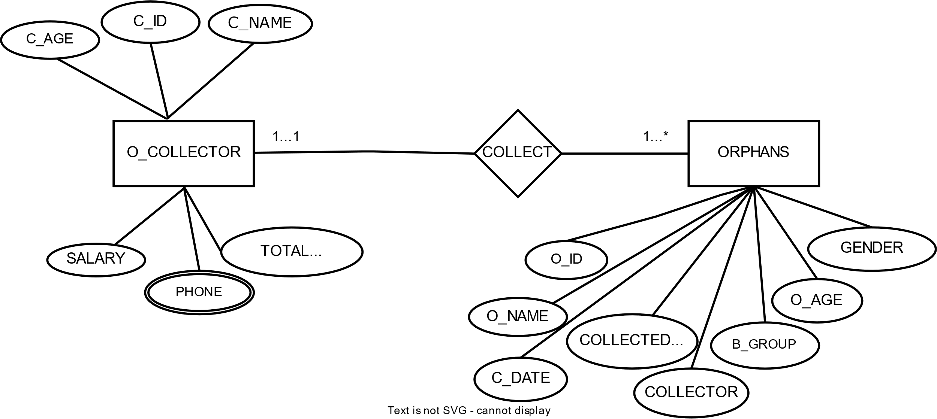

**COLLECT:**

UNF:

C_ID, C_NAME, TOTAL_COLLECTION, SALARY, C_AGE, PHONE, O_ID, O_NAME, C_DATE, COLLECTED_FROM, COLLECTOR, B_GROUP, GENDER, O_AGE

1NF:

PHONE is a multivalued attribute

C_ID, C_NAME, TOTAL_COLLECTION, SALARY, C_AGE, O_ID, O_NAME, C_DATE, COLLECTED_FROM, COLLECTOR, B_GROUP, GENDER, O_AGE

2NF:

1. C_ID, C_NAME, TOTAL_COLLECTION, SALARY, C_AGE, PHONE_ID
2. PHONE_ID, PHONE
3. O_ID, O_NAME, C_DATE, COLLECTED_FROM, COLLECTOR, B_GROUP, GENDER, O_AGE, C_ID

3NF:

1. C_ID, C_NAME, TOTAL_COLLECTION, SALARY, C_AGE, PHONE_ID
2. PHONE_ID, PHONE
3. O_ID, O_NAME, B_GROUP, GENDER, O_AGE, C_ID
4. O_ID, C_DATE, COLLECTED_FROM, COLLECTOR

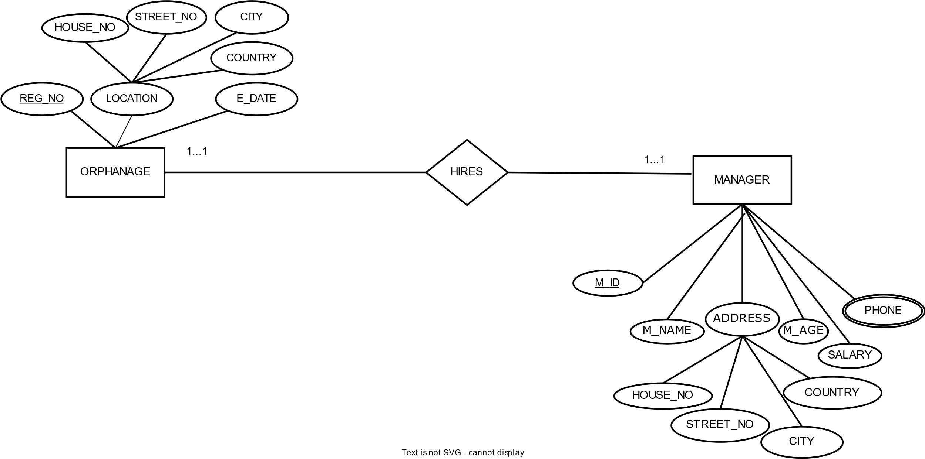

**HIRES:**

UNF:

REG_NO, E_DATE, HOUSE_NO, STREET_NO, CITY, COUNTRY, M_ID, M_NAME, HOUSE_NO, STREET_NO, CITY, COUNTRY, M_AGE, SALARY, PHONE

1NF:

PHONE is a multivalued attribute.

REG_NO, E_DATE, HOUSE_NO, STREET_NO, CITY, COUNTRY, M_ID, M_NAME, HOUSE_NO, STREET_NO, CITY, COUNTRY, M_AGE, SALARY

2NF:

1. REG_NO, E_DATE, HOUSE_NO, STREET_NO, CITY, COUNTRY
2. M_ID, M_NAME, HOUSE_NO, STREET_NO, CITY, COUNTRY, M_AGE, SALARY, REG_NO, PHONE_ID
3. PHONE_ID, PHONE

3NF:

1. REG_NO, E_DATE, ADD_ID
2. ADD_ID, HOUSE_NO, STREET_NO, CITY, COUNTRY
3. M_ID, M_NAME, M_AGE, SALARY, REG_NO, PHONE_ID, ADD_ID
4. ADD_ID, HOUSE_NO, STREET_NO, CITY, COUNTRY
5. PHONE_ID, PHONE

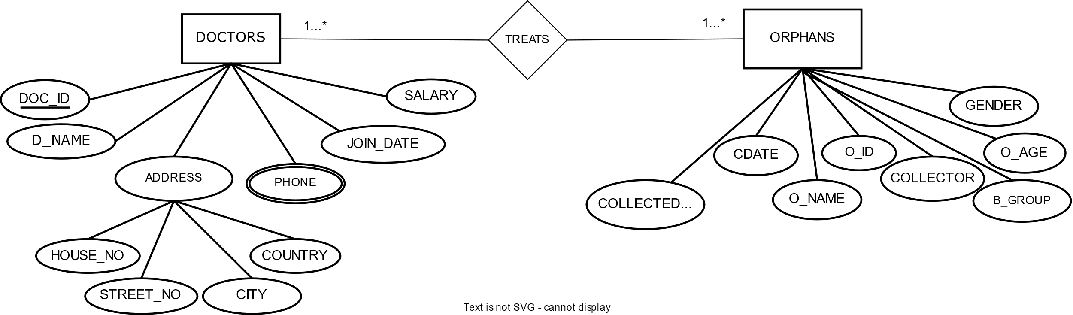

TREATS:

UNF:

DOC_ID, DO_NAME, HOUSE_NO, STREET_NO, CITY, COUNTRY, PHONE, JOIN_DATE, SALARY, O_ID, O_NAME, C_DATE, COLLECTED_FROM, COLLECTOR, B_GROUP, GENDER, O_AGE

1NF:

PHONE is a multivalued attribute

DOC_ID, DO_NAME, HOUSE_NO, STREET_NO, CITY, COUNTRY, JOIN_DATE, SALARY, O_ID, O_NAME, C_DATE, COLLECTED_FROM, COLLECTOR, B_GROUP, GENDER, O_AGE

2NF:

1. DOC_ID, DO_NAME, HOUSE_NO, STREET_NO, CITY, COUNTRY, JOIN_DATE, SALARY, PHONE_ID
2. PHONE_ID, PHONE
3. O_ID, O_NAME, C_DATE, COLLECTED_FROM, COLLECTOR, B_GROUP, GENDER, O_AGE, DOC_ID

3NF:

1. DOC_ID, DO_NAME, JOIN_DATE, SALARY, ADD_ID, PHONE_ID
2. ADD_ID, HOUSE_NO, STREET_NO, CITY, COUNTRY
3. PHONE_ID, PHONE
4. O_ID, O_NAME, B_GROUP, GENGER, O_AGE, DOC_ID
5. O_I D, C_DATE, COLLECTED_FROM, COLLECTOR

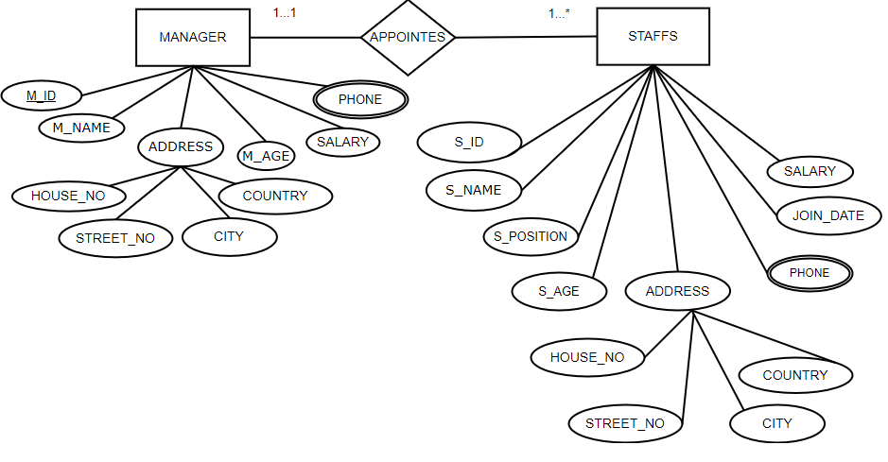

APPOINTS:

UNF:

M_ID, M_NAME, HOUSE_NO, STREET_NO, CITY, COUNTRY, M_AGE, SALARY, PHONE, S_ID, S_NAME, S_POSITION, S_AGE, HOUSE_NO, STREET_NO, CITY, COUNTRY, PHONE, JOIN_DATE, SALARY

1NF:

PHONE is a multivalued attribute.

M_ID, M_NAME, HOUSE_NO, STREET_NO, CITY, COUNTRY, M_AGE, SALARY, S_ID, S_NAME, S_POSITION, S_AGE, HOUSE_NO, STREET_NO, CITY, COUNTRY, JOIN_DATE, SALARY

2NF:

1. M_ID, M_NAME, HOUSE_NO, STREET_NO, CITY, COUNTRY, M_AGE, SALARY, PHONE_ID
2. PHONE_ID, PHONE
3. S_ID, S_NAME, S_POSITION, S_AGE, HOUSE_NO, STREET_NO, CITY, COUNTRY, JOIN_DATE, SALARY, M_ID, PHONE_ID
4. PHONE_ID, PHONE

3NF:

1. M_ID, M_NAME, M_AGE, SALARY, ADD_ID, PHONE_ID
2. ADD_ID, HOUSE_NO, STREET_NO, CITY, COUNTRY
3. PHONE_ID, PHONE
4. S_ID, S_NAME, S_AGE, JOIN_DATE, M_ID, ADD_ID, PHONE_ID
5. S_ID, S_POSITION, SALARY
6. ADD_ID, HOUSE_NO, STREET_NO, CITY, COUNTRY
7. PHONE_ID, PHONE

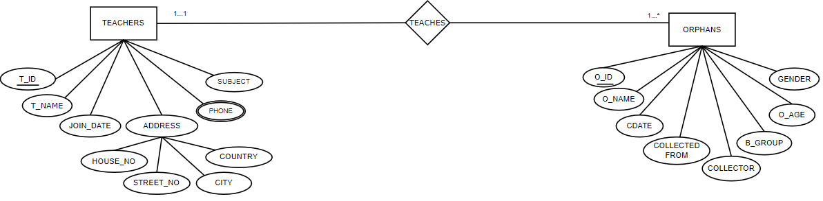

**TEACHES:**

UNF:

T_ID, T_NAME, SUBJECT, PHONE, JOIN_DATE, HOUSE_NO, STREET_NO, CITY, COUNTRY, O_ID, O_NAME, GENDER, O_AGE, B_GROUP, C_DATE, COLLECTED FROM, COLLECTOR

1NF:

PHONE is a multivalued attribute.

T_ID, T_NAME, SUBJECT, JOIN_DATE, HOUSE_NO, STREET_NO, CITY, COUNTRY, O_ID, O_NAME, GENDER, O_AGE, B_GROUP, C_DATE, COLLECTED FROM, COLLECTOR

2NF:

1. T_ID, T_NAME, SUBJECT, JOIN_DATE, HOUSE_NO, STREET_NO, CITY, COUNTRY, PHONE_ID
2. PHONE_ID, PHONE
3. O_ID, O_NAME, GENDER, O_AGE, B_GROUP, C_DATE, COLLECTED FROM, COLLECTOR, T_ID

3NF:

1. T_ID, T_NAME, SUBJECT, JOIN_DATE, PHONE_ID, ADD_ID
2. PHONE_ID, PHONE
3. ADD_ID HOUSE_NO, STREET_NO, CITY, COUNTRY
4. O_ID, O_NAME, GENDER, O_AGE, B_GROUP, T_ID
5. O_I D, C_DATE, COLLECTED_FROM, COLLECTOR

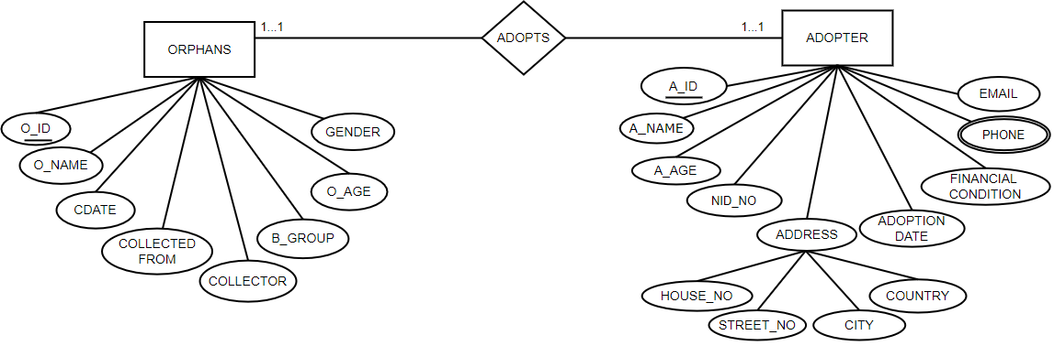

**ADOPTS:**

UNF:

A_ID, A_NAME, A_AGE, NID_NO, EMAIL, PHONE, FINANCIAL CONDITION, ADOPTION DATE, HOUSE_NO, STREET_NO, CITY, COUNTRY, O_ID, O_NAME, GENDER, O_AGE, B_GROUP, C_DATE, COLLECTED FROM, COLLECTOR

1NF:

PHONE is a multivalued attribute.

A_ID, A_NAME, A_AGE, NID_NO, EMAIL, FINANCIAL CONDITION, ADOPTION DATE, HOUSE_NO, STREET_NO, CITY, COUNTRY, O_ID, O_NAME, GENDER, O_AGE, B_GROUP, C_DATE, COLLECTED FROM, COLLECTOR.

2NF:

1. A_ID, A_NAME, A_AGE, NID_NO, EMAIL, FINANCIAL_CONDITION, ADOPTION_DATE, HOUSE_NO, STREET_NO, CITY, COUNTRY, PHONE_ID
2. PHONE_ID, PHONE
3. O_ID, O_NAME, GENDER, AGE, BG, C_DATE, COLLECTED FROM, COLLECTOR, A_ID.

3NF:

1. A_ID, A_NAME, A_AGE, NID_NO, EMAIL, FINANCIAL CONDITION, ADOPTION DATE, PHONE_ID, ADD_ID
2. PHONE_ID, PHONE
3. ADD_ID, HOUSE_NO, STREET_NO, CITY, COUNTRY
4. O_ID, O_NAME, GENDER, AGE, B_GROUP, A_ID
5. O_I D, C_DATE, COLLECTED_FROM, COLLECTOR

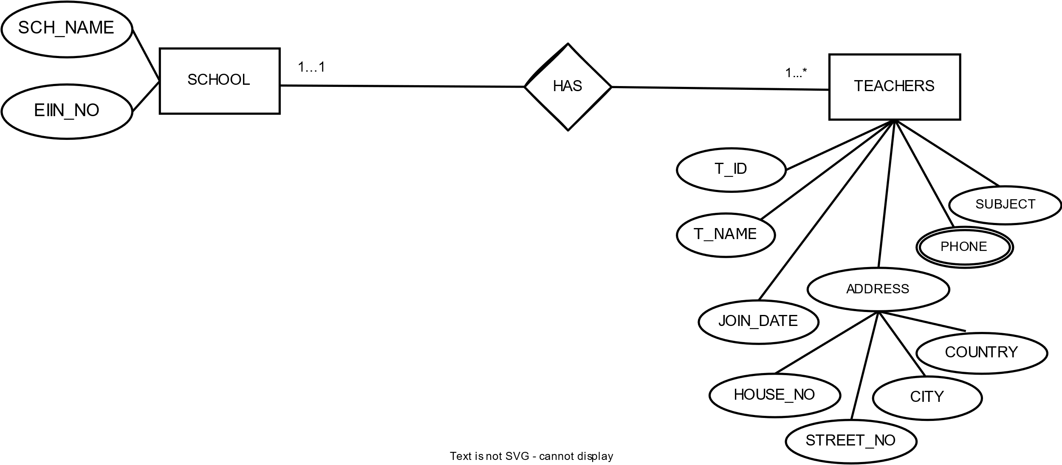

HAS:

UNF:

EIIN_NO, SCH_NAME, T_ID, T_NAME, SUBJECT, PHONE, JOIN_DATE, HOUSE_NO, STREET_NO, CITY, COUNTRY

1NF:

PHONE is a multivalued attribute.

EIIN_NO, SCH_NAME, T_ID, T_NAME, SUBJECT, JOIN_DATE, HOUSE_NO, STREET_NO, CITY, COUNTRY

2NF:

1. EIIN_NO, SCH_NAME
2. T_ID, T_NAME, SUBJECT, JOIN_DATE, HOUSE_NO, STREET_NO, CITY, COUNTRY, EIIN_NO, PHONE_ID
3. PHONE_ID, PHONE

3NF:

1. EIIN_NO, SCH_NAME
2. T_ID, T_NAME, SUBJECT, JOIN_DATE, EIIN_NO, PHONE_ID, ADD_ID
3. PHONE_ID, PHONE
4. ADD_ID, HOUSE_NO, STREET_NO, CITY, COUNTRY